**Health analyzation and visualization to participate in sports**

**Nature of work**: Novel solution/ indigenous design to a problem/ challenge

**Need for Project**

*Need for this is that people are dying because of running because they don’t check that are they eligible. It also helps sports authorities to decide who is better sprinter that is un-biased selection. In a single program.*

**Scientific Principle(s)/ Concepts:**

* DATA USE
* EVALUATION
* GRAPHICS
* MODULAR SYSTEM

**Materials Used: -**

**Hardware**

* **Laptop**

**Software**

* **Python**
* **Tkinter**
* **Pandas**

**How to Make This: -**

* **To visualize, use turtle**
* **Calculate mps (Meters per second) of both players**
* **Make two blobs/turtle and make them move their mps steps to visualize their race (if you want then you can tweak their step)**
* **That’s it for visualization it shows race between two players**
* **Create ‘survey.py’ file**
* **For survey you can use tkinter’s message box askyesno**
* **You need to create two excel files named ‘elegiblity records.xlsx’ and ‘runner_data.xlsx’**
* **Create ‘add_athelite’ file**
* **make a function named add**
* **ask player’s details and add that to data**
* **make a function named check_eligiblity**
* **use Player’s data to perform BFP check, use your survey module to perform a parq test**
* **add that to your eligibility data**
* **make a single program for all features**

**What can we add more**

* **We can add parq+ test**
* **We can auto create excel files**
* **We can make a gui instead of terminal-based program**
* **We can use kivy library instead of tkinter.**

**Reference**

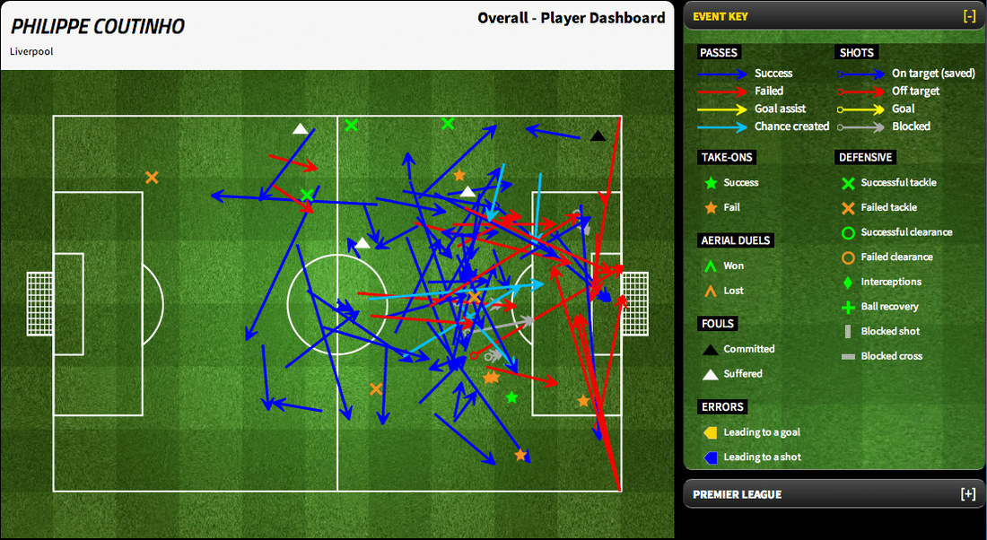

**Prediction**

**Race**

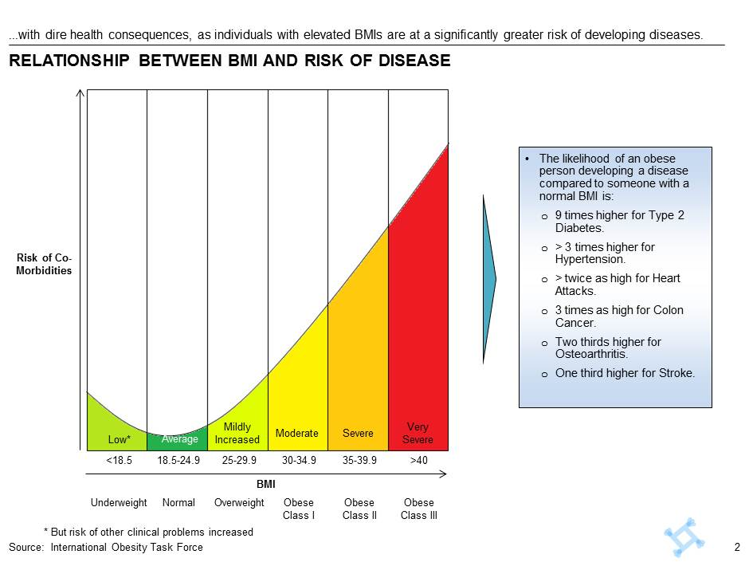

**Risk of Obesity**

**- Ishan Luhani**